It is similar to EBS, the advantage of the EFS is:

* Provides a more secured storage
* It can house data from many instances unlike the EBS
* It can scale to any size without disrupting applications

Amazon EFS offers two storage classes:

* The Standard storage class
* The infrequent Access Storage class

**FUNCTIONS / USES OF AMAZON EFS:**

* Used for containers and server less applications
* Analytics & Machine Learning
* Web serving & content management
* Application testing & development
* Media & Entertainments
* Database backups etc

**STEPS TO CREATE EFS**

* Login to your Amazon console, create an instance
* Go to git bash and login: ssh -i Downloads/wavecafe-prod-nvir.pem [ec2-user@ec2-3-17-147-254.us-east-2.compute.amazonaws.com](mailto:ec2-user@ec2-3-17-147-254.us-east-2.compute.amazonaws.com)
* sudo –i
* cd /var/www/html/
* Create a security group for your EFS (In inbound rule: connection should be allowed from NFS and security group of the web server)

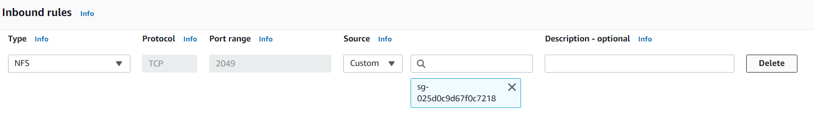

* Go to EFS service in your console and click create file system
* When you get to Network access, select the security group you created for the efs

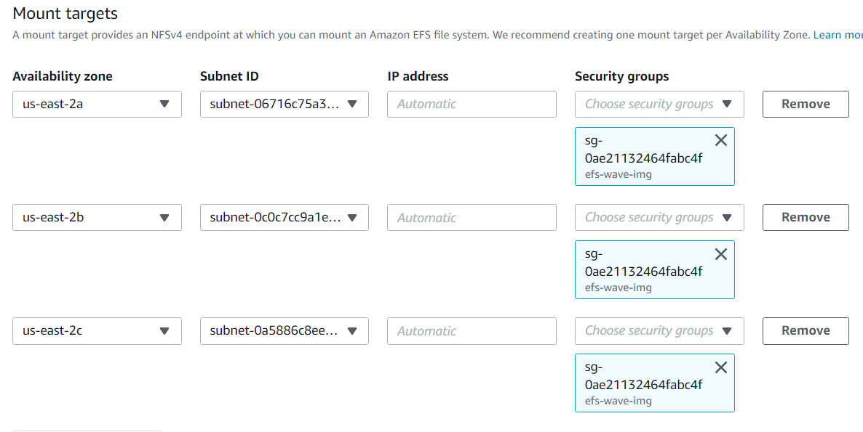

* Then click on create at the end
* You can access it with IAM user or Access points
* When you click on create, check the left pane and click on Access points
* Click on create Access points
* select your access points and scroll down to create
* You need to note:
* If you are using Amazon Linux for your instance: (Follow the guide to install)

<https://docs.aws.amazon.com/efs/latest/ug/installing-amazon-efs-utils.html>

* Any other Linux flavor: Use same link but carefully scroll down

<https://docs.aws.amazon.com/efs/latest/ug/installing-amazon-efs-utils.html>

* To mount follow the link & steps below:

Mounting with EFS access points …. since we activated access point above

<https://docs.aws.amazon.com/efs/latest/ug/mounting-access-points.html>

* Open Notepad++ ….. paste the code and edit using your details from the console

file-system-id efs-mount-point efs _netdev,tls,accesspoint=access-point-id 0 0

(get your file system id from console) efs-mount-point efs _netdev,tls,accesspoint=(get your access point ID) 0 0

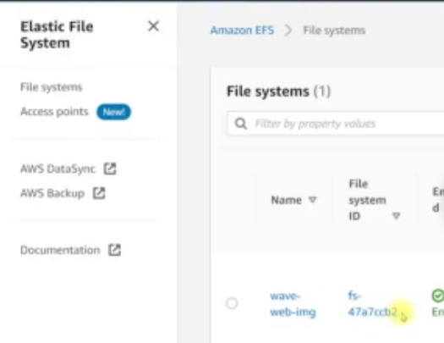

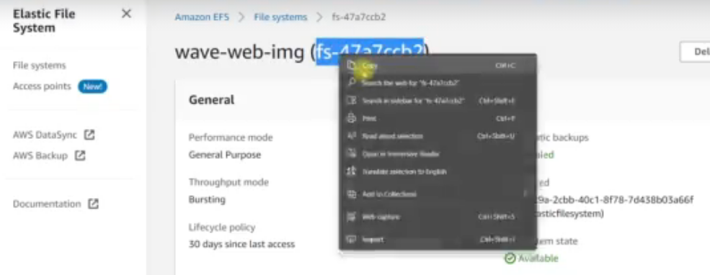

* The code you edited: copy it and return to your git bash

(get your file system id from console) efs-mount-point efs _netdev,tls,accesspoint=(get your access point ID) 0 0

* create a dir for backup: mkdir /tmp/img-backup
* move to the backed up dir: mv img/* /tmp/img-backup
* vi /etc/fstab

paste the copied code here: (get your file system id from console) efs-mount-point efs _netdev,tls,accesspoint=(get your access point ID) 0 0

* Delete the efs-mount-point and replace with /var/www/html/img …. (save and quit)
* Now test it: mount –fav
* Create an AMI which would be useful for Autoscaling group
* If you see an error or it is timing out check the security group of your EFS if it allows access from your web server
* Remember to restore your data back after the testing: mv /tmp/img-backup/* img/